SAMPLE THANK YOU LETTER TO ELECTED OFFICIAL(S)
On your letterhead:
[school/district website]
[insert date]
Honorable ___________________
Address

Dear _______________________,
On behalf of the students, teachers, parents and administrators of [insert name of school or district] , we wish to thank you for visiting our school and experiencing the value of learning in the arts first-hand. Our entire school community was thrilled to have you join us! We hope that you enjoyed your time with us and that your experience moved and empowered you as much as it empowers our students every time they engage in an arts lesson.
[Insert highlights from the elected official's visit. Try to keep it brief, but personal and touching]
If we want to ensure that our students become creative and inspired thinkers and citizens, an education in the arts is essential. Our children need your support. We hope that our school can be a resource for you. Please feel free to contact us any time.
Thank you again for sharing your valuable time with us.
Sincerely,

President, __________ PTA Principal, [insert school name]

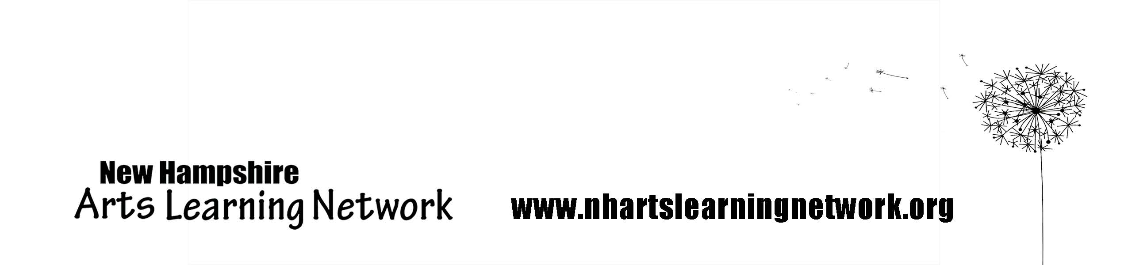
Enclosures: [If available, enclose copies of news clippings from the event, a signed statement of beliefs, photos, and anything else that will add a personal touch to your message. List what you have enclosed with your letter here]

