SAMPLE INVITATION LETTER TO ELECTED OFFICIAL(S)
On your school/district letterhead
[insert date]
Honorable ___________________
Address
Re: Arts Learning in Action: Celebrate Arts Education Month in March (2013)
Dear____________________,
Our learning community at [insert name of school/district] is pleased to invite you to experience arts learning in action at our school on [insert date] at [insert time] o’clock.
[choose one of these quotes]
In Measuring Up, the New Hampshire Arts Education Data Project Report, Virginia Barry, New Hampshire Commissioner of Education, wrote:
I believe the arts are an important component of education for the whole child, preparing students more completely for success in college and careers. The skills developed by studying the arts include collaboration, creativity, problem-solving, flexibility, and perseverance; and these are critical to the 21st century skills needed to succeed in college, career, and life. The arts enliven our schools with music, visual arts, dance, and theatre and showcase our students’ abilities in these areas. (March, 2011)

(or, if you prefer):
In the official blog of the U.S. Department of Education, Secretary of Education Arne Duncan wrote on October 17, 2011:
As core academic subjects, the arts and humanities equip young persons with the capacities to learn from the past, question the present, and envision new possibilities for the future. They are essential to a well-rounded, P-12 education for all Americans. I join with President Obama and the First Lady in rejecting the notion that the arts, history, foreign languages, geography, and civics are ornamental offerings that can be cut from schools during a fiscal crunch.
Working with the NH Arts Learning Network, [Insert name of your school/district/organization] is committed to supporting arts education for all students. We invite you to witness the power of arts learning during the month of March, designated as Arts Education Month. Please join us for….[short description of your event]
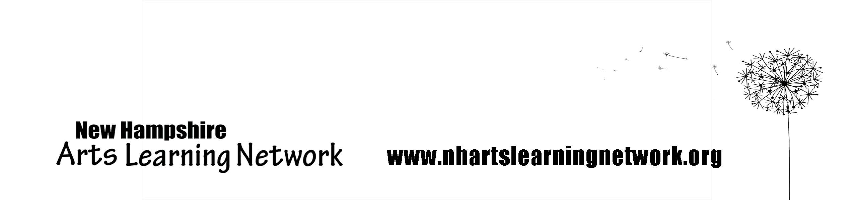
We look forward to your participation. Please RSVP by [insert date] to: [insert name and contact information].
Sincerely,
[insert signature]
Principal (or correct title) [insert school name]

